Anterior Cervical Discectomy and Fusion: A Three Year Retrospective
M. Craig Hixson, Undergraduate, Department of Biology, Tennessee Technological University, P.O. Box 5063, Cookeville, TN 38505

Table of Contents
Summary……………...2
Key Words…………….2
Introduction……………3
Methods……………….3
Expected Results…….8
Acknowledgements…..8
Curriculum Vitae………9
Ethics Statement……..10
Timeline……………….11
Literature Cited……….12
Budget…………………13

Project Summary
Anterior cervical discectomy and fusion (ACDF) has been shown to be a successful method of treating patients who present with pathologies related to cervical spine dysfunction. However, there is only a limited amount of literature that discusses the effectiveness of this procedure with respect to patient’s age, sex, and history of tobacco use. Also, there have been very few large-scale trials conducted to compare its efficacy when certain procedural variables, such as graft material, instrumentation, and number of levels fused are taken into account. Therefore, this study has been undertaken to determine the role that variables such as age, sex, tobacco use and surgical variations play in the outcomes of ACDF patients. Said outcomes shall be evaluated by conducting follow-up interview with patients who are at least 36 months post-operation. The results of these interviews will be compared to pre-operative indications and subjected to statistical testing to determine average improvements and statistical significance. In doing this, it is the goal of the author to derive affirmative conclusions related to the effectiveness of this procedure. Furthermore, this study will help identify which, if any, personal or surgical factors are more likely to result in improved outcomes.

Key Words: Cervical, Discectomy, Fusion, ACDF, Allograft, Autograft

Introduction
Discectomy and fusion of the cervical spine through an anterior approach (ACDF) has been a common surgical procedure used to treat a variety of spinal anomalies for many years. Most existing literature supports the conclusion that ACDF is an effective method for alleviating pain and restoring functional capacity for the general patient population. (Kwon 2005) Furthermore, long-term benefits have also been shown to be common in these patients, with the most frequent complications being related to adjacent level myelopathy and/or stenosis. (Emery 1998) Comparison of pre- and post-operative visual analog pain scales (VAS) and Oswestry Disability Questionnaires, as well as Neck Disability Indices have been accepted as standard methods of evaluating the benefits of different spinal treatments. (Palit 1999) Though the general advantages of this procedure have been adequately prove, literature searches produce very limited, if any, studies preformed to compare long term results with respect to patient age, sex, and tobacco use. Other variables, such as differences in grafting materials used have been evaluated and shown to produce positive outcomes regardless of which method is used. (Samartzis 2003) Such conclusions suggest that proficiency on behalf of the surgeon and appropriate patient selection are perhaps the most important factors related to positive outcomes. Thus, it is the purpose of this study to determine which, if any, demographic criteria correlate to superior post-operative results. The effectiveness of allograft and autograft procedures will also be evaluated in an effort to further the understanding of the effect, if significant, that this difference in procedure illicits. Thereby either supporting existing results or suggesting that further research is needed on the topic by disproving said conclusions.

Methods and Materials
Results shall be analyzed for 102 patients who underwent cervical discectomy and attempted fusion between 1996 and 2002. All patients shall be presented with written informed consent forms approved by the Memorial Hospital (Chattanooga,TN) Internal Review Board. Patients who do not sign informed consent shall be disqualified from the study. All interviews and radiographs shall be preformed at the Center for Sports Medicine and Orthopaedics (Chattanooga, TN). Outcomes will be evaluated by having patients complete subjective, follow-up, questionnaires regarding their general level of function (Table 1), completion of VAS (Levi 2003) (Figure 1) and Oswestry (Fairbank et al. 1980) (Figure 2) surveys, and having new radiographs taken and analyzed by an independent radiologist. All data provided by the patients will be compared to pre-operative results of the same surveys. Patients’ results will be grouped by age, sex, tobacco use, grafting material used. Mean values will be determined for each measure, for each group. The respective groups will then be compared using ANOVA testing to determine if the null hypothesis should be rejected.

Table 1
MR#
NAME
BIRTH YEAR
GENDER
SURGEON
DATE OF SURGERY
PROCEDURE
INSTRUMENTATION
LEVELS FUSED
GRAFT MATERIAL
COMPLICATIONS
PRE-OP ANALOG PAIN SCALE
POST-OP ANALOG PAIN SCALE
PRE-OP OSWESTRY
POST-OP OSWESTRY
CHRONIC MEDICAL PROBLEMS
TOBACCO USE
WORK RELATED
LITIGATION
WORK PRE-OP
WORK POST-OP
SAME JOB
NECK PAIN
ARM PAIN
NON-OPERATIVE CARE
LENGTH OF SYMPTOMS
WOULD YOU HAVE SURGERY AGAIN
PHYSICAL THERAPY POST-OP
COMENTS

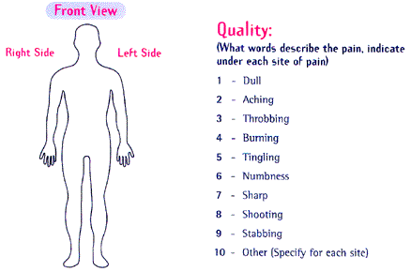

Figure 1 Visual Analog Pain Scale
(Sample taken from www.womenandpain.com. Actual survey varied only in representative sketch of human body)

Oswestry Chronic Low Back Pain Questionnaire
SECTION 1-- Pain Intensity
A. The pain comes and goes and is very mild.
B. The pain is mild and does not vary much.
C. The pain comes and goes and is moderate.
D. The pain is moderate and does not vary much.
E. The pain comes and goes and is severe.
F. The pain is severe and does not vary much.
SECTION 2-- Personal Care
A. I would not have to change my way of washing or dressing in order to avoid pain.
B. I do not normally change my way of washing or dressing even though it causes some pain.
C. Washing and dressing increases the pain, but I manage not to change my way of doing it.
D. Washing and dressing increases the pain and I find it necessary to change my way of doing it.
E. Because of the pain, I am unable to do some washing and dressing without help.
F. Because of the pain, I am unable to do any washing or dressing without help.
SECTION 3-- Lifting
A. I can lift heavy weights without extra pain.
B. I can lift heavy weights, but it causes extra pain.
C. Pain prevents me from lifting heavy weights off the floor.
D. Pain prevents me from lifting heavy weights off the floor, but I can manage if they are conveniently positioned, e.g., on a table.
E. Pain prevents me from lifting heavy weights, but I can manage light to medium weights if they are conveniently positioned.
F. I can only lift very light weights, at the most.
SECTION 4-- Walking
A. Pain does not prevent me from walking any distance.
B. Pain prevents me from walking more than one mile.
C. Pain prevents me from walking more than 1/2 mile.
D. Pain prevents me from walking more than 1/4 mile.
E. I can only walk while using a cane or on crutches.
F. I am in bed most of the time and have to crawl to the toilet.
SECTION 5-- Sifting
A. I can sit in any chair as long as I like without pain.
B. I can only sit in my favorite chair as long as I like.
C. Pain prevents me from sitting more than one hour.
D. Pain prevents me from sitting more than 1/2 hour.
E. Pain prevents me from sitting more than ten minutes.
F. Pain prevents me from sitting at all.

Figure 2 Oswestry Survey
SECTION 6 -- Standing
A. I can stand as long as I want without pain.
B. I have some pain while standing, but it does not increase with time.
C. I cannot stand for longer than one hour without increasing pain.
D. I cannot stand for longer than 1/2 hour without increasing pain.
E. I cannot stand for longer than ten minutes without increasing pain.
F. I avoid standing, because it increases the pain straight away.
SECTION 7 -- Sleeping
A. I get no pain in bed.
B. I get pain in bed, but it does not prevent me from sleeping well.
C. Because of pain, my normal night’s sleep is reduced by less than one-quarter
D. Because of pain, my normal night’s sleep is reduced by less than one-half.
E. Because of pain, my normal night’s sleep is reduced by less than three-quarters.
F. Pain prevents me from sleeping at all.
SECTION 8--Social Life
A. My social life is normal and gives me no pain.
B. My social life is normal, but increases the degree of my pain.
C. Pain has no significant effect on my social life apart from limiting my more energetic interests, e.g., dancing, etc.
D. Pain has restricted my social life and I do not go out very often.
E. Pain has restricted my social life to my home.
F. I have hardly any social life because of the pain.
SECTION 9-- Traveling
A. I get no pain while traveling.
B. I get some pain while traveling, but none of my usual forms of travel make it any worse.
C. I get extra pain while traveling, but it does not compel me to seek alternative forms of travel.
D. I get extra pain while traveling which compels me to seek alternative forms of travel.
E. Pain restricts all forms of travel.
F. Pain prevents all forms of travel except that done lying down.
SECTION 10-- Changing Degree of Pain
A. My pain is rapidly getting better.
B. My pain fluctuates, but overall is definitely getting better.
C. My pain seems to be getting better, but improvement is slow at present.
D. My pain is neither getting better nor worse.
E. My pain is gradually worsening.
F. My pain is rapidly worsening.

Figure 2 Cont. Oswestry Survey
Expected Results and Benefits
This study will help solidify existing evidence that ACDF is an effective method for treating patients who present with cervical pain or radiculopathy. Furthermore, the effectiveness of several different types of instrumentation will be evaluated, thus showing if particular types of instrumentation may improve the likelihood of successful operative outcomes.

Acknowledgements
S. Craig Humphreys M. D. Center for Sports Medicine and Orthopaedics. Chattanooga, TN
Scott D. Hodges M.D. Center for Sports Medicine and Orthopaedics. Chattanooga, TN
Peggy Levi R.N. Center for Sports Medicine and Orthopaedics. Chattanooga, TN
Peggy Davis Center for Sports Medicine and Orthopaedics. Chattanooga, TN

Curriculum Viate
M. Craig Hixson
642 North Peachtree, Cookeville,TN 38501
931-529-9875
MCHixson21@tntech.edu

Education
 | Tennessee Technological University, Cookeville, TN
 | B.S. in Biology |  | Current
Minor: Chemistry
Minor: English
 | Soddy Daisy High School, Soddy Daisy, TN
 | High School Diploma |  | 1996-2000

Related Experience
 |  | Center for Sports Medicine and Orthopaedics
 |  | Researcher  Assisted physicians with the execution of national and site-based clinical research. | 2003-2004
 |  | Center for Sports Medicine and Orthopaedics
 |  | Physical Therapy Technician  Assisted physical therapists with the implementation of rehabilitation programs for patients with orthopedic injuries and dysfunction. | 2003-2004

Publications and papers
- “A Comparison of Outcomes of Anterior Cervical Discectomy and Fusion in Patients with and without Radicular Symptoms”
- “Ankylosing Spondylitis”
- “Treatment of Common Ankle Injuries in Adolescents”
Paper presented to Hamilton Country Dept. of Education After-School Care 2003
- “Current Techniques in the Treatment of Lumbar Spinal Injuries”
- Review: ”Parathyroid Cell Proliferatoin in Normal and Chronic Renal Failure Rats: the Effects of Calcium, Phosphate, and Vitamin D”

Languages
- English – native language
- French – basic competence

Memberships
- Sigma Phi Epsilon Fraternity
- National Athletic Trainer’s Association
- South Eastern Athletic Trainer’s Association

Ethics Statement

- Conduct research and in a manner that is consistent with accepted scientific and teaching methods, maintaining the highest standards of honesty and integrity in all professional endeavors.
- Comply with all laws and regulations that apply to the treatment of study organisms and other aspects of professional conduct.
- Expose scientific fraud and other forms of professional misconduct whenever it is found.
- Be civil and respectful in professional interactions, avoiding discrimination, based on race, gender, sexual orientation, religion, or age. Treat colleagues, students, and employees fairly.
- Be constructive and professional in evaluating the work of colleagues, students, and employees.
- Provide recognition of past and present contributions of others to science, and present one’s professional opinions only on those topics for which one has training and knowledge.
- Promote the free and open exchange of information, not withholding information to substantiate a personal or scientific point of view.
- Be candid about potential conflicts of interest in the conduct of professional duties.
(Excerpts taken from American Institute of Biological Sciences Ethics Statement)

Project Timeline
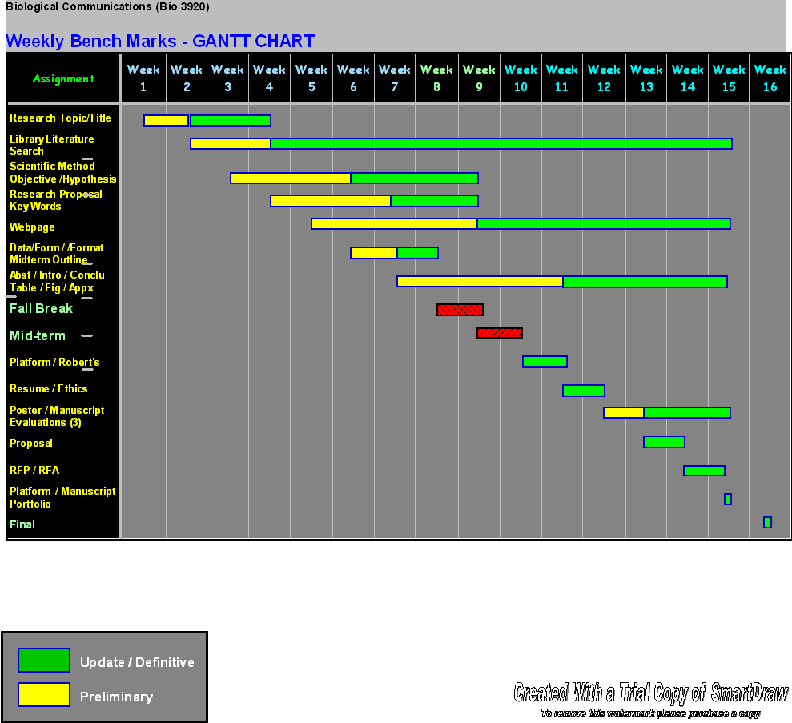

Literature Cited
1. McAfee P, Bohlman H, Ducker T, Zeidman S, Goldstein J. 1995 One-stage anterior cervical decompression and posterior stabilization. The Journal of Bone and Joint Surgery. 77(12): 1791-1800

2. Moreland DB, Asch HL, Clabeaux DE, Castiglia GJ, Czajka GA, Lewis PJ, Egnatchik JG, Cappuccino A, Huynh L. 2004 Anterior cercvical discectomy and fusion with implantable titanium cage: initial impressions, patient outcomes and comparison to fusion with allograft. Spine. 4(2):184-91.

3. Kwon B, Kim DH, Marvin A, Jenis LG. 2005 Outcomes following anterior cervical discectomy and fusion: the role of interbody disc height, angulation, and spinous process distance. Journal of Spinal Disorder Technology. 18(4):304-8.

4. Palit M, Schofferman J, Goldthwaite N, Reynolds J, Kerner M, Keaney D, Lawrence-Miyasaki L. 1999. Anterior discectomy and fusion for the management of neck pain. Spine.1;24(21):2224-8.

5. Bohlman HH, Emery SE, Goodfellow DB, Jones PK. 1993. Robinson anterior cervical discectomy and arthrodesis for cervical radiculopathy. Long-Term follow-up of one hundered and twenty-two patients. Journal of Bone and Joint Surgery. 9:75:1298-1307.

6. Emery Sanford, Bohlman Henry, Bolesta Michael, Jones Paul. 1998. Anterior Cervical Decompression and Arthrodesis for the Treatment of Cervical Spondylotic Myelopathy. Two to Seventeen-Year Follow-Up. Journal of Bone and Joint Surgery. 80:941-51.

7. Samartzis D, Shen FH, Matthews DK, Yoon ST, Goldberg EJ, An HS. 2003. Comparison of allograft to autograft in multilevel anterior cervical discectomy and fusion with rigid plate fixation. Spine. 3(6):415-9

8. Floyd T. 2000. A meta-analysis of autograft versus allograft in anterior cervical fusion. European Spine Journal. 9(5):398-403.

Proposed Budget

Office Supplies | $100
Travel | $100
Coffee | $50
Food | $200
TOTAL | $550

